ГУАП

КАФЕДРА № 43

ОТЧЕТ   
ЗАЩИЩЕН С ОЦЕНКОЙ

ПРЕПОДАВАТЕЛЬ

|  |  |  |  |  |
| --- | --- | --- | --- | --- |
| Доцент |  |  |  | С.В. Щекин |
| должность, уч. степень, звание |  | подпись, дата |  | инициалы, фамилия |

|  |
| --- |
| ОТЧЕТ О ЛАБОРАТОРНОЙ РАБОТЕ №6 |
| «Организация доступа к аппаратным компонентам мобильного устройства» |
| по курсу: Программирование мобильных устройств |
|  |
|  |

РАБОТУ ВЫПОЛНИЛ

|  |  |  |  |  |  |
| --- | --- | --- | --- | --- | --- |
| СТУДЕНТ ГР. № | 4831 |  | 12.02.2021 |  | К.А.Корнющенков |
|  |  |  | подпись, дата |  | инициалы, фамилия |

Санкт-Петербург 2020

1. **Цель работы**

Получение навыков использования в разрабатываемых мобильных приложениия доступа к компонентам аппаратного обеспечения мобильных устройств.

1. **Задания**

Дополнить приложение, разработанное в рамках одной из предыдущих лабораторных работ, добавив в него работу с аппаратным обеспечение мобильного устройства (камера, светодиод подсветки, датчики и т.п.)

1. **Исходный код**

Код класса, который отвечает за работу с фонариком и камерой

import UIKit

import AVFoundation

class LighteViewController: UIViewController,

UIImagePickerControllerDelegate,

UINavigationControllerDelegate {

@IBOutlet weak var mySwitch: UISwitch!

@IBOutlet weak var myImage: UIImageView!

let picker = UIImagePickerController()

override func viewDidLoad() {

super.viewDidLoad()

mySwitch.addTarget(self, action: #selector(switchAction), for: .allEvents)

picker.delegate = self

}

@objc

func switchAction() {

guard

let device = AVCaptureDevice.default(for: AVMediaType.video),

device.hasTorch

else { return }

do {

try device.lockForConfiguration()

device.torchMode = mySwitch.isOn ? .on : .off

device.unlockForConfiguration()

} catch {

print(error.localizedDescription)

}

}

@IBAction func cameraAction(_ sender: UIButton) {

picker.sourceType = .camera

self.present(picker, animated: true, completion: nil)

}

@IBAction func gallaryAction(_ sender: UIButton) {

picker.sourceType = .photoLibrary

self.present(picker, animated: true, completion: nil)

}

func imagePickerController(_ picker: UIImagePickerController, didFinishPickingMediaWithInfo info: [UIImagePickerController.InfoKey : Any]) {

myImage.image = info[UIImagePickerController.InfoKey.originalImage] as? UIImage

dismiss(animated: true, completion: nil)

}

}

Код интерфейса

<!--Lighte View Controller-->

<scene sceneID="eiM-RL-tbJ">

<objects>

<viewController id="BZq-R2-xqN" customClass="LighteViewController" customModule="Laba" customModuleProvider="target" sceneMemberID="viewController">

<view key="view" contentMode="scaleToFill" id="dyc-QW-8zp">

<rect key="frame" x="0.0" y="0.0" width="414" height="842"/>

<autoresizingMask key="autoresizingMask" widthSizable="YES" heightSizable="YES"/>

<subviews>

<label opaque="NO" userInteractionEnabled="NO" contentMode="left" horizontalHuggingPriority="251" verticalHuggingPriority="251" text="Тут будет фонарик " textAlignment="center" lineBreakMode="tailTruncation" baselineAdjustment="alignBaselines" adjustsFontSizeToFit="NO" translatesAutoresizingMaskIntoConstraints="NO" id="fCs-Ji-CG8">

<rect key="frame" x="16" y="16" width="382" height="35"/>

<fontDescription key="fontDescription" type="system" pointSize="29"/>

<nil key="textColor"/>

<nil key="highlightedColor"/>

</label>

<switch opaque="NO" contentMode="scaleToFill" horizontalHuggingPriority="750" verticalHuggingPriority="750" contentHorizontalAlignment="center" contentVerticalAlignment="center" translatesAutoresizingMaskIntoConstraints="NO" id="die-p8-97l">

<rect key="frame" x="182.5" y="151" width="51" height="31"/>

</switch>

<imageView clipsSubviews="YES" userInteractionEnabled="NO" contentMode="scaleAspectFit" horizontalHuggingPriority="251" verticalHuggingPriority="251" translatesAutoresizingMaskIntoConstraints="NO" id="7ao-we-z4T">

<rect key="frame" x="57" y="271" width="300" height="300"/>

<constraints>

<constraint firstAttribute="width" constant="300" id="Wy7-F8-3y3"/>

<constraint firstAttribute="height" constant="300" id="rGv-U0-JFA"/>

</constraints>

</imageView>

<label opaque="NO" userInteractionEnabled="NO" contentMode="left" horizontalHuggingPriority="251" verticalHuggingPriority="251" text="Доступ к камере" textAlignment="natural" lineBreakMode="tailTruncation" baselineAdjustment="alignBaselines" adjustsFontSizeToFit="NO" translatesAutoresizingMaskIntoConstraints="NO" id="kID-q2-ZRN">

<rect key="frame" x="139.5" y="221" width="135" height="21"/>

<fontDescription key="fontDescription" type="system" pointSize="17"/>

<nil key="textColor"/>

<nil key="highlightedColor"/>

</label>

<button opaque="NO" contentMode="scaleToFill" contentHorizontalAlignment="center" contentVerticalAlignment="center" buttonType="system" lineBreakMode="middleTruncation" translatesAutoresizingMaskIntoConstraints="NO" id="63C-wg-r0K">

<rect key="frame" x="180.5" y="606" width="53" height="30"/>

<state key="normal" title="камера"/>

<connections>

<action selector="cameraAction:" destination="BZq-R2-xqN" eventType="touchUpInside" id="iSo-Ib-zzd"/>

</connections>

</button>

<button opaque="NO" contentMode="scaleToFill" contentHorizontalAlignment="center" contentVerticalAlignment="center" buttonType="system" lineBreakMode="middleTruncation" translatesAutoresizingMaskIntoConstraints="NO" id="HNg-mL-b62">

<rect key="frame" x="178.5" y="671" width="57" height="30"/>

<state key="normal" title="галерея"/>

<connections>

<action selector="gallaryAction:" destination="BZq-R2-xqN" eventType="touchUpInside" id="4dZ-31-S2M"/>

</connections>

</button>

</subviews>

<viewLayoutGuide key="safeArea" id="zyR-Dj-iAF"/>

<color key="backgroundColor" systemColor="systemBackgroundColor"/>

<constraints>

<constraint firstItem="63C-wg-r0K" firstAttribute="top" secondItem="7ao-we-z4T" secondAttribute="bottom" constant="35" id="0Tm-sm-VJ9"/>

<constraint firstItem="7ao-we-z4T" firstAttribute="centerX" secondItem="dyc-QW-8zp" secondAttribute="centerX" id="3GM-Go-9ib"/>

<constraint firstItem="7ao-we-z4T" firstAttribute="top" secondItem="kID-q2-ZRN" secondAttribute="bottom" constant="29" id="Can-qD-aQT"/>

<constraint firstItem="zyR-Dj-iAF" firstAttribute="trailing" secondItem="fCs-Ji-CG8" secondAttribute="trailing" constant="16" id="Eja-BA-zfr"/>

<constraint firstItem="die-p8-97l" firstAttribute="centerX" secondItem="dyc-QW-8zp" secondAttribute="centerX" id="MIm-eH-fxs"/>

<constraint firstItem="HNg-mL-b62" firstAttribute="centerX" secondItem="dyc-QW-8zp" secondAttribute="centerX" id="OCO-fw-Oy6"/>

<constraint firstItem="HNg-mL-b62" firstAttribute="top" secondItem="63C-wg-r0K" secondAttribute="bottom" constant="35" id="V2H-ph-rhT"/>

<constraint firstItem="63C-wg-r0K" firstAttribute="centerX" secondItem="dyc-QW-8zp" secondAttribute="centerX" id="W8I-f7-5Oi"/>

<constraint firstItem="fCs-Ji-CG8" firstAttribute="leading" secondItem="zyR-Dj-iAF" secondAttribute="leading" constant="16" id="Yir-gE-pm0"/>

<constraint firstItem="fCs-Ji-CG8" firstAttribute="top" secondItem="zyR-Dj-iAF" secondAttribute="top" constant="16" id="YwI-7C-C7F"/>

<constraint firstItem="die-p8-97l" firstAttribute="top" secondItem="fCs-Ji-CG8" secondAttribute="bottom" constant="100" id="ca9-sD-mLx"/>

<constraint firstItem="7ao-we-z4T" firstAttribute="centerY" secondItem="dyc-QW-8zp" secondAttribute="centerY" id="hNW-j1-6ge"/>

<constraint firstItem="kID-q2-ZRN" firstAttribute="centerX" secondItem="dyc-QW-8zp" secondAttribute="centerX" id="wga-7i-3dm"/>

</constraints>

</view>

<navigationItem key="navigationItem" id="189-j1-HBI"/>

<connections>

<outlet property="myImage" destination="7ao-we-z4T" id="XGJ-Sf-ycU"/>

<outlet property="mySwitch" destination="die-p8-97l" id="3mM-Iv-NsE"/>

</connections>

</viewController>

<placeholder placeholderIdentifier="IBFirstResponder" id="1qo-QZ-YFe" userLabel="First Responder" customClass="UIResponder" sceneMemberID="firstResponder"/>

</objects>

<point key="canvasLocation" x="113" y="808"/>

</scene>

<!--Second View Controller-->

<scene sceneID="yqK-R0-8nA">

<objects>

<viewController id="aQA-W1-WfR" customClass="SecondViewController" customModule="Laba" customModuleProvider="target" sceneMemberID="viewController">

<view key="view" contentMode="scaleToFill" id="2ki-7X-jIZ">

<rect key="frame" x="0.0" y="0.0" width="414" height="842"/>

<autoresizingMask key="autoresizingMask" widthSizable="YES" heightSizable="YES"/>

<subviews>

<slider opaque="NO" contentMode="scaleToFill" contentHorizontalAlignment="center" contentVerticalAlignment="center" value="0.5" minValue="0.0" maxValue="1" translatesAutoresizingMaskIntoConstraints="NO" id="So9-Yl-gRq">

<rect key="frame" x="51" y="584" width="312" height="31"/>

</slider>

<segmentedControl opaque="NO" contentMode="scaleToFill" contentHorizontalAlignment="left" contentVerticalAlignment="top" segmentControlStyle="plain" selectedSegmentIndex="0" translatesAutoresizingMaskIntoConstraints="NO" id="34l-Dk-fiv">

<rect key="frame" x="141.5" y="166" width="131" height="32"/>

<segments>

<segment title="First"/>

<segment title="Second"/>

</segments>

</segmentedControl>

<label opaque="NO" userInteractionEnabled="NO" contentMode="left" horizontalHuggingPriority="251" verticalHuggingPriority="251" text="Экран 2" textAlignment="natural" lineBreakMode="tailTruncation" baselineAdjustment="alignBaselines" adjustsFontSizeToFit="NO" translatesAutoresizingMaskIntoConstraints="NO" id="fPv-nJ-lLl">

<rect key="frame" x="134.5" y="39" width="145" height="48"/>

<fontDescription key="fontDescription" type="system" pointSize="40"/>

<nil key="textColor"/>

<nil key="highlightedColor"/>

</label>

</subviews>

<viewLayoutGuide key="safeArea" id="GoZ-sC-oyA"/>

<color key="backgroundColor" systemColor="systemBackgroundColor"/>

<constraints>

<constraint firstItem="34l-Dk-fiv" firstAttribute="top" secondItem="fPv-nJ-lLl" secondAttribute="bottom" constant="79" id="3PR-DG-Qax"/>

<constraint firstItem="34l-Dk-fiv" firstAttribute="centerX" secondItem="2ki-7X-jIZ" secondAttribute="centerX" id="8L8-h4-s2H"/>

<constraint firstItem="So9-Yl-gRq" firstAttribute="centerX" secondItem="2ki-7X-jIZ" secondAttribute="centerX" id="Bgx-0k-03m"/>

<constraint firstItem="So9-Yl-gRq" firstAttribute="leading" secondItem="GoZ-sC-oyA" secondAttribute="leading" constant="53" id="fOC-gf-LJb"/>

<constraint firstItem="GoZ-sC-oyA" firstAttribute="bottom" secondItem="So9-Yl-gRq" secondAttribute="bottom" constant="194" id="kHm-uM-FTg"/>

<constraint firstItem="fPv-nJ-lLl" firstAttribute="top" secondItem="GoZ-sC-oyA" secondAttribute="top" constant="39" id="rFJ-7C-35u"/>

<constraint firstItem="fPv-nJ-lLl" firstAttribute="centerX" secondItem="2ki-7X-jIZ" secondAttribute="centerX" id="x2G-hw-YPj"/>

</constraints>

</view>

<navigationItem key="navigationItem" id="ddX-B2-GpX"/>

</viewController>

<placeholder placeholderIdentifier="IBFirstResponder" id="M0V-Fk-Rc1" userLabel="First Responder" customClass="UIResponder" sceneMemberID="firstResponder"/>

</objects>

<point key="canvasLocation" x="1124.6376811594205" y="76.339285714285708"/>

</scene>

</scenes>

1. **Результаты работы программы**

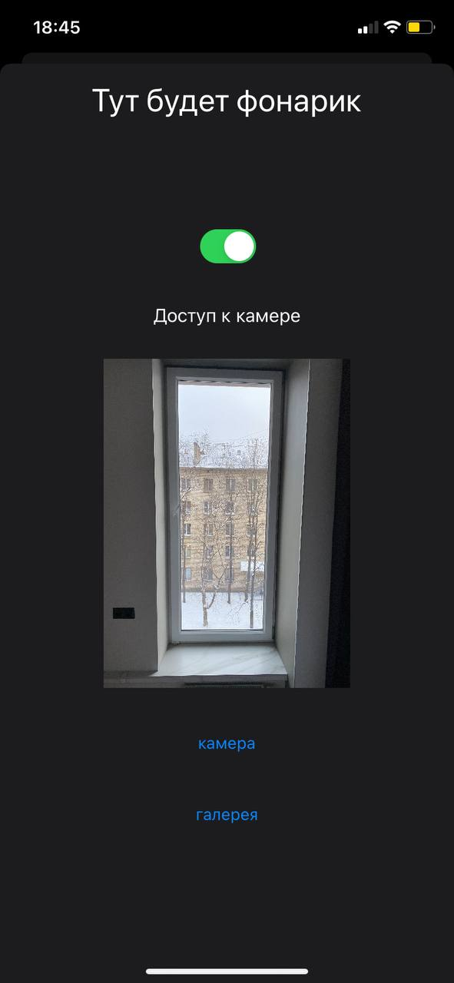

Экран для работы с камерой и фонариком

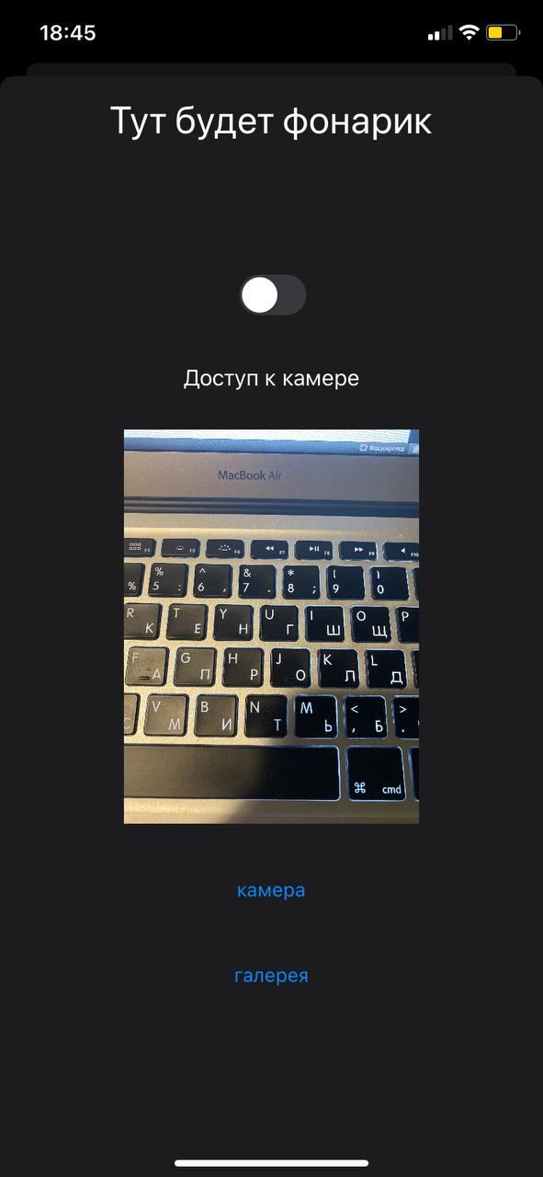

Экран для работы с камерой и фонариком

1. **Вывод**

В ходе выполнения лабораторной работы были получены навыки работы с аппаратной частью девайса